**App.js:**

import { BrowserRouter, Routes, Route, Link } from 'react-router-dom';

import Home from './Home';

import TrainersList from './TrainerList';

import TrainerDetails from './TrainerDetail';

import trainersMock from './trainersMock';

function App() {

    return (

        <BrowserRouter>

            <div style={{ marginLeft: '20px', fontFamily: 'Arial' }}>

                <h1>My Academy Trainers App</h1>

                <nav style={{ marginBottom: '20px' }}>

                    <Link to="/" style={{ marginRight: '10px' }}>Home</Link>

                    <Link to="/trainers" style={{ marginLeft: '10px' }}>Show Trainers</Link>

                </nav>

                <Routes>

                    <Route path="/" element={<Home />} />

                    <Route path="/trainers" element={<TrainersList trainers={trainersMock} />} />

                    <Route path="/trainers/:id" element={<TrainerDetails />} />

                </Routes>

            </div>

        </BrowserRouter>

    );

}

export default App;

**Home.js:**

function Home() {

    return (

        <div>

            <h2>Welcome to My Academy trainers page</h2>

        </div>

    );

}

export default Home;

**trainer.js:**

class Trainer {

    constructor(trainerId, name, email, phone, technology, skills) {

        this.trainerId = trainerId;

        this.name = name;

        this.email = email;

        this.phone = phone;

        this.technology = technology;

        this.skills = skills;

    }

}

export default Trainer;

**TrainerDetail.js:**

import { useParams } from 'react-router-dom';

import trainersMock from './trainersMock';

function TrainerDetails() {

    const { id } = useParams();

    const trainer = trainersMock.find(t => t.trainerId === id);

    if (!trainer) return <p>Trainer not found</p>;

    return (

        <div>

            <h2>Trainers Details</h2>

            <p><strong>{trainer.name} ({trainer.technology})</strong></p>

            <p>{trainer.email}</p>

            <p>{trainer.phone}</p>

            <ul>

                {trainer.skills.map((skill, index) => (

                    <li key={index}>{skill}</li>

                ))}

            </ul>

        </div>

    );

}

export default TrainerDetails;

**TrainerList.js:**

import { Link } from 'react-router-dom';

function TrainersList({ trainers }) {

    return (

        <div>

            <h2>Trainers List</h2>

            <ul>

                {trainers.map(trainer => (

                    <li key={trainer.trainerId}>

                        <Link to={`/trainers/${trainer.trainerId}`}>{trainer.name}</Link>

                    </li>

                ))}

            </ul>

        </div>

    );

}

export default TrainersList;

**trainermock.js:**

import Trainer from "./trainer";

const trainersMock = [

    new Trainer('t-syed8', 'Syed Khaleelullah', 'khaleelullah@cognizant.com', '97676516962', '.NET', ['C#', 'SQL Server', 'React', '.NET Core']),

    new Trainer('t-jojo', 'Jojo Jose', 'jojo@cognizant.com', '9897199231', 'Java', ['Java', 'JSP', 'Angular', 'Spring']),

    new Trainer('t-elisa', 'Elisa Jones', 'elisa@cognizant.com', '9871212235', 'Python', ['Python', 'Django', 'Angular'])

];

export default trainersMock;

**Home:**

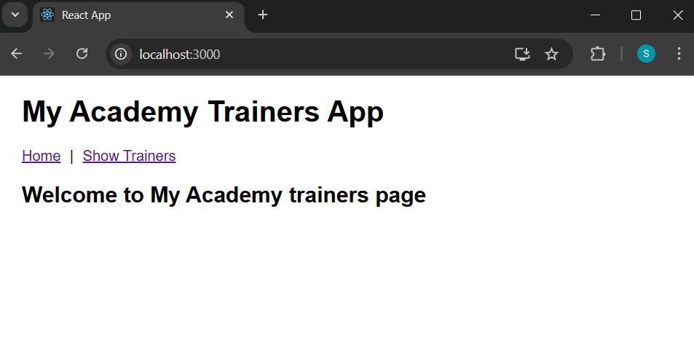

**Trainers List:**

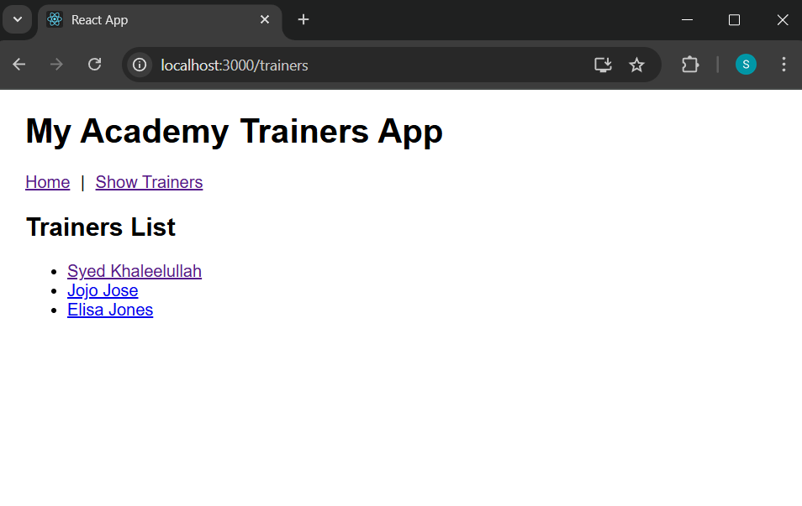

**Trainers Details:**

